Name :
Hafsa Waseem
Roll no :
Su92-bssem-s24-014
Subject :
Mad (lab)
Submitted to :
Sir Muhammad Abdullah
Task no 7 :
Question no 1 :
Main dart code :
import 'package:flutter/material.dart';
void main() {
runApp(const MyApp());
}
class MyApp extends StatelessWidget {
const MyApp({super.key});
@override
Widget build(BuildContext context) {
return MaterialApp(
debugShowCheckedModeBanner:false,

title: 'Smart App Navigation',
theme: ThemeData(
primarySwatch: Colors.blue,
useMaterial3: true,
),
home: const MainTaskScreen(),
);
}
}
class MainTaskScreen extends StatelessWidget {
const MainTaskScreen({super.key});
void _openFilterSheet(BuildContext context) {
showModalBottomSheet(
context: context,
isScrollControlled: true,
backgroundColor: Colors.transparent,
builder: (context) => const FilterBottomSheet(),
);
}
@override
Widget build(BuildContext context) {
return Scaffold(
appBar: AppBar(
title: const Text("App Dashboard"),
centerTitle: true,
actions: [
IconButton(
icon: const Icon(Icons.tune_rounded),
onPressed: () => _openFilterSheet(context),
),
],
),
drawer: Drawer(
child: Column(
children: [
UserAccountsDrawerHeader(
decoration: const BoxDecoration(color: Color(0xFFEEEEEE)),
currentAccountPicture: const CircleAvatar(
backgroundColor: Colors.white,
child: Icon(Icons.person, size: 45, color: Colors.grey),
),
accountName: const Text(
"User Name",
style: TextStyle(color: Colors.black, fontWeight: FontWeight.bold),
),
accountEmail: const Text(
"Address\nWe make your priority as our first priority",
style: TextStyle(color: Colors.grey, fontSize: 12),
),
),
Expanded(
child: ListView(
padding: EdgeInsets.zero,
children: [
_drawerTile(Icons.grid_view_rounded, "Shop By Category", context),
_drawerTile(Icons.favorite_border, "Your Favourite", context),
_drawerTile(Icons.star_outline, "Rate Our App", context),
_drawerTile(Icons.help_outline, "Help", context),
_drawerTile(Icons.share_outlined, "Share", context),
_drawerTile(Icons.info_outline, "About Us", context),
],
),
),
],
),
),
body: const Center(
child: Column(
mainAxisAlignment: MainAxisAlignment.center,
children: [
Icon(Icons.touch_app, size: 50, color: Colors.blue),
SizedBox(height: 10),
Text(
"Swipe from left for Menu\nor\nClick top-right icon for Filters",
textAlign: TextAlign.center,
style: TextStyle(fontSize: 16, color: Colors.grey),
),
],
),
),
);
}
Widget _drawerTile(IconData icon, String title, BuildContext context) {
return ListTile(
leading: Icon(icon, color: Colors.black54),
title: Text(title),
onTap: () {
Navigator.pop(context);
Navigator.push(
context,
MaterialPageRoute(builder: (context) => ContentPage(title: title)),
);
},
);
}
}
class FilterBottomSheet extends StatelessWidget {
const FilterBottomSheet({super.key});
@override
Widget build(BuildContext context) {
return Container(
padding: const EdgeInsets.symmetric(horizontal: 20, vertical: 15),
decoration: const BoxDecoration(
color: Colors.white,
borderRadius: BorderRadius.vertical(top: Radius.circular(35)),
),
child: Column(
mainAxisSize: MainAxisSize.min,
crossAxisAlignment: CrossAxisAlignment.start,
children: [
const Center(
child: Text("Filters", style: TextStyle(fontSize: 22, fontWeight: FontWeight.bold)),
),
const SizedBox(height: 25),
const Text("Interested in", style: TextStyle(fontWeight: FontWeight.bold)),
const SizedBox(height: 12),
Row(
children: [
_filterOption("Girls", true),
_filterOption("Boys", false),
_filterOption("Both", false),
],
),
const SizedBox(height: 25),
const Text("Distance: 40km", style: TextStyle(fontWeight: FontWeight.w500)),
Slider(value: 40, max: 100, activeColor: Colors.pinkAccent[100], onChanged: (v) {}),
const SizedBox(height: 15),
const Text("Age: 20-28", style: TextStyle(fontWeight: FontWeight.w500)),
RangeSlider(values: const RangeValues(20, 28), max: 100, activeColor: Colors.pinkAccent[100], onChanged: (v) {}),
const SizedBox(height: 30),
SizedBox(
width: double.infinity,
height: 55,
child: ElevatedButton(
style: ElevatedButton.styleFrom(
backgroundColor: Colors.pinkAccent[100],
shape: const StadiumBorder(),
),
onPressed: () => Navigator.pop(context), // Close action [cite: 31]
child: const Text("Continue", style: TextStyle(color: Colors.white, fontSize: 18)),
),
),
],
),
);
}
Widget _filterOption(String text, bool isSelected) {
return Expanded(
child: Container(
margin: const EdgeInsets.symmetric(horizontal: 5),
padding: const EdgeInsets.symmetric(vertical: 12),
decoration: BoxDecoration(
color: isSelected ? Colors.pinkAccent[100] : Colors.white,
border: Border.all(color: Colors.grey[300]!),
borderRadius: BorderRadius.circular(12),
),
child: Center(
child: Text(
text,
style: TextStyle(color: isSelected ? Colors.white : Colors.black87),
),
),
),
);
}
}
class ContentPage extends StatelessWidget {
final String title;
const ContentPage({super.key, required this.title});
@override
Widget build(BuildContext context) {
return Scaffold(
appBar: AppBar(title: Text(title)),
body: Center(child: Text("This is the $title Screen")),
);
}
}
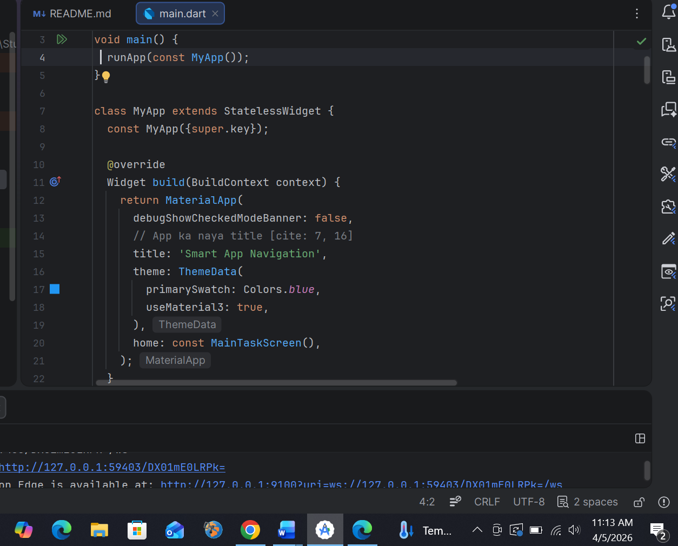

Output :
